Holy Cross College
Science Department
Year 9 Light Test Mark: /40

Part A: Multiple Choices [10 marks] Full Name: ………………………………….

- Mirrors will “……” light rays.

  - scatter
  - refract
  - transmit
  - reflect

- An object that produces light is:

  - opaque.
  - transparent.
  - translucent.
  - luminous.

- Compared to visible light, ultraviolet radiation has:

  - lower frequency and higher energy.
  - higher frequency and lower energy.
  - higher frequency and higher energy.
  - lower frequency and lower energy.

- Refraction can make it difficult to judge the depth of water. How is the light shown from the point in the diagram bent?

  - Light from the point is bent towards the normal, making the point seem deeper.
  - Light from the point is bent away from the normal, making the point seem shallower.
  - Light from the point is bent towards the normal, making the point seem shallower.
  - Light from the point is bent away from the normal, making the point seem deeper.

- Which material can be classified as translucent?

  - Red cardboard.
  - Window glass.
  - Frosted glass.
  - Carpet.

- The speed of light in air is:

  - 300 000 000 m/sec.
  - 300 000 m/sec.
  - 340 m/sec.
  - 300 km/sec.

- A convex lens is a piece of glass or plastic used to bend light. It is:

A even in thickness
B narrower at each end than at its centre
C wider at each end than at its centre
D narrow at one end and thick at the opposite end

- Radio waves are a type of radiation found on the electromagnetic spectrum. They have:

  - High frequency
  - Large wavelength
  - High energy
  - High magnetism

- Compare the way that dark and light substances absorb and emit radiation.

  - Dark objects absorb less and release less radiation than light coloured objects.
  - Dark objects absorb less and release more radiation than light coloured objects.
  - Dark objects absorb more and release more radiation than light coloured objects.
  - Dark objects absorb more and release less radiation than light coloured objects.

- Which of the following statements about light is false?

  - Light can travel through opaque substances.
  - Light can travel through space.
  - The speed of travelling light can change.
  - The density of a substance determines how light behaves when entering it.

Part B: Short Questions [28 marks]

- a) Label the following illustration of the human eye.
[6]
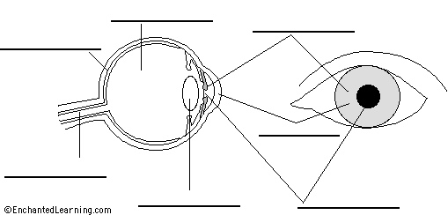

b) Name the lens shown below. It is the kind of lens found in a magnifying glass.
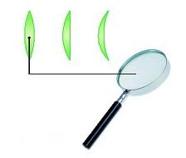
[1]

It is a ……………………………… lens.

c) What happens to a beam of light that passes through one of these lenses?

[1]
……………………………………………………………………………………………………………..

d) Describe how the eye focuses light.
[3]
……………………………………………………………………………………………………………..

……………………………………………………………………………………………………………..

……………………………………………………………………………………………………………..

……………………………………………………………………………………………………………..

- a) Label the following diagram of a wave.
[4]

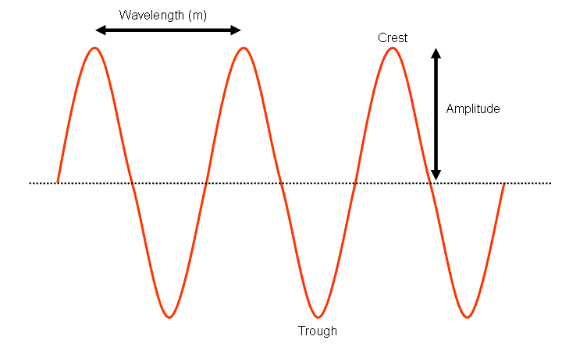

b) Complete the diagram of the electromagnetic spectrum by naming the remaining bands.
[4]
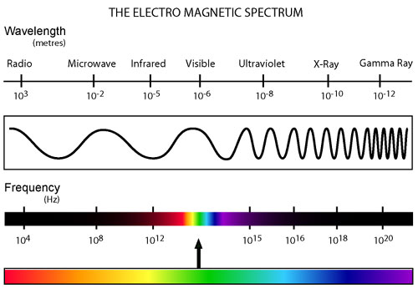

Of the visible light spectrum, which colour of light has the lowest frequency?
[1]
……………………………………………

Of the visible light spectrum, which colour of light has the highest energy?
[1]
……………………………………………

- Show what happens to the path of light in the following scenarios.

  - Light comes in at an angle to a mirror. On the diagram, construct the normal and show the path of the reflected ray.
[2]

  - Light comes in at an angle to a glass block. On the diagram, construct the normal and a possible path for the ray in the glass. Show the same as it exits the glass.
Air
Glass
Air

[4]

Name this process.
[1]
………………………………………………

Describe why light behaves in this way as it enters and exits the glass.
[2]
……………………………………………………………………………………………………………..

……………………………………………………………………………………………………………..

……………………………………………………………………………………………………………..
END OF TEST

